http://birdingecotours.co.za
info@birdingecotours.co.za
Austria and Hungary: Scouting Trip Report – August 2014
By Jason Boyce

Unfortunately, this trip had to be conducted in one of the worst birding months, because it was a scouting trip for us. On our actual future tours, which will take place in the spring, the birding will be much better.
Day 1. Lower Austria, Rotheau, Ochsattel pass, and surrounds
Our scouting venture to Austria and Hungary began on the 20th of August in a small town called Rotheau, not far from Vienna. We were fortunate enough to have in our local guide one of the foremost experts on European birds and other wildlife.
During the first morning’s birding it was fairly cold, and a soft rain was starting to interfere with our birding. Even so we managed to make a couple of productive stops and got a few good views of Eurasian Treecreeper, Wood Warbler, Eurasian Bullfinch, and a whole host of Tits, made up of European Crested, Willow, Coal, Great, Eurasian Blue, and Marsh. The call of the mighty Black Woodpecker was heard a couple of times, but no visuals were to be had, yet.
The highlight of the day for us were the dozen Common Mergansers that we found later that afternoon on a river on the outskirts of town.
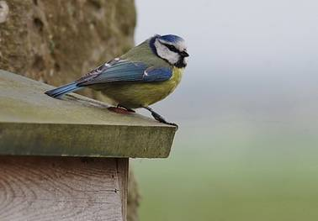
Blue Tit
Day 2. Travel to Hungary
The morning started off with a mammal, a red deer, while we were getting our necessary supplies. Golden Eagles frequent this area, but we were not fortunate enough to get any views. A couple of other raptors were around, though, including European Honey and Common Buzzards and a Eurasian Sparrowhawk. Finally at the Ochsattel pass we managed to get great visuals of the magnificent Black Woodpecker. What an outstandingly amazing bird!
We crossed into Hungary that afternoon in beautiful, sunny weather. Some of the first birds we encountered were Eurasian Hobby, Western Marsh Harrier, Common Kestrel, and a single Lesser Whitethroat calling from the roadside. Birds were more plentiful today, and we also managed to add two more Woodpeckers, Great Spotted and Grey-headed, to our woodpecker tally.
The landscape had now changed drastically; we saw a drier open landscape dominating the area, as well as large water bodies and reed beds. During one particular stop we made alongside one of the reed beds we managed to get great visuals of Bearded Reedling. White Stork nests lined the entrances to many small villages, and many waterfowl were traveling overhead to roosting sites and different bodies of water.
Before it got too late in the day we made a stop at Fertő-Hanság National Park. Here we added good numbers of shorebirds as well as White-tailed Eagle. We ended the day with good looks at Syrian Woodpecker.
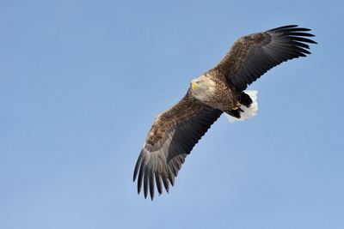
White-tailed Eagle
Day 3. Neusiedler See – Seewinkel National Park
Staying just south of Fertő-Hanság National Park in the town of Fertőd, it was a very short drive back into Austria to Neusiedler See – Seewinkel National Park. One of our main targets for the day would be Great Bustard, and Neusiedler See – Seewinkel delivered. A group of four Great Bustards were spotted early in the morning – what a fantastic sight! A number of other species that we encountered in the open fields were Common Cuckoo, Yellowhammer, White Wagtail, and a two species of warbler – Garden Warbler and Eurasian Blackcap – enjoying the elderberries.
Later that morning we enjoyed large numbers of waterfowl and shorebirds, including Dunlin, Red Knot, Spotted Redshank, Pied Avocet, Northern Lapwing, Great Crested Grebe, Red-crested Pochard, and Yellow-legged Gull. Other species of interest today were Purple Heron, Collared Flycatcher, Black Redstart, Ferruginous Duck, Black Tern, and Common Ringed Plover.
Back on the Hungarian Side of the national park we had an incredible sighting of Eastern Imperial Eagle flying directly overhead. This caused chaos among all the waterfowl – quite a spectacle.
We ended off the day in a small park in town, where Short-toed Treecreeper and Middle Spotted Woodpecker were obliging, while Hawfinch made us work hard for brief views.
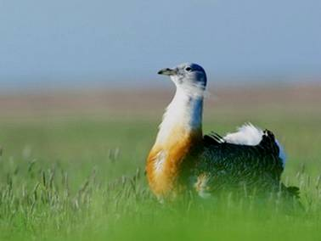
Great Bustard
Day 4. Ferencmajor ponds ringing station
One of the trip highlights was joining the ringing station at Ferencmajor for a morning. They would run this station for about a month, ringing/banding every day. This way they could obtain valuable data over a prolonged period of time.
In addition to the attractions at the ringing station itself, the surrounding area had some nice settling ponds, which produced a number of great birds. These included Common Pochard, Eurasian Wigeon, Gadwall, Bearded Reedling, Eurasian Spoonbill, Little Gull, Common Kingfisher, Common Crane, and Black Stork. Savi’s Warbler was the star bird at the ponds that morning for us – getting good looks at any skulker like this takes some doing. Upon leaving we bumped into a European Pied Flycatcher – a good way to end the morning’s birding.
With a fair amount of travel time still ahead for the day, we grabbed some lunch and headed out to the Kiskunság area. Fantastic birds along the way included White-tailed Eagle, Eurasian Sparrowhawk, Eurasian Golden Oriole, Whinchat, and a magnificent Saker Falcon.
The landscape opened up into agricultural fields and some rolling hills, where Northern Wheatear, Western Yellow Wagtail, and Crested Lark became more prominent.
Before the day turned to darkness we still managed to sneak in great views of European Roller, Montagu’s Harrier, and a stunning Little Owl.
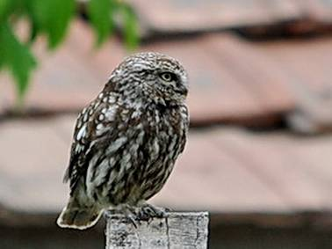
Little Owl
Day 5. Kunsági Major
On our fifth morning, near the town of Kerekegyháza, we targeted a few species that we hadn’t managed to locate so far on the trip. We were successful in finding Woodlark, Common Skylark, and Eurasian Stone-curlew. European Greenfinch and Green Woodpecker were nice additions late in the trip, while on the raptor front we found two more Common Buzzards, another Common Kestrel, another Saker Falcon, and a beautiful female Western Marsh Harrier.
The best of the day was still to come, however, with our third sighting of Great Bustard for the trip. What a fabulous place this is to come to if you are after this magnificent bird. Although the species, listed as Vulnerable, has suffered rapid population reductions across its wide range, Central Europe, including sites visited on this tour, remains a good stronghold for these sought-after giants.
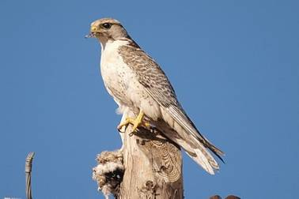
Saker Falcon
Day 6. Kiskunság to Budapest
Our last full birding day of what was a leisurely and very enjoyable birding trip had arrived too soon. We made our way into the hills of the Budapest area from the flatlands of Kiskunság – with one detour, though.
On the way our local guide said he would take us past a spot known for a species of owl. With our love for owls, of course, we had no choice but to go with the flow. A roosting site of Long-eared Owl! This was a wonderful way to start the morning. A good five individuals, sitting quietly, were looking back at us with piercing eyes.
En route we stopped off to get some supplies at a filling station and had the most amazing sighting of Eastern Imperial Eagle not more than thirty meters above our heads. What a sight!
The hills and forests of Hor were our last site, where we were hoping for both White-backed and Three-toed Woodpeckers. Unfortunately we could not locate the latter, but we did find a cracking adult White-backed Woodpecker. Other highlights were Lesser Spotted Woodpecker, Northern Raven, Hawfinch, Common Linnet, and yet another sighting of Black Woodpecker.
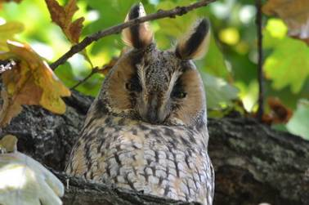
Long-eared Owl
Day 7 - Departure
The tour had come to an end as on the next morning our guide dropped us off at the airport in Budapest for our long flight back to Johannesburg, South Africa.
We were lucky enough to get a good feel for the area during this scouting trip, and we enjoyed very good hospitality through both Austria and Hungary. We are grateful for all the laughs, and of course for many a great Central European bird.

AUSTRIA AND HUNGARY BIRD LIST
English Name (IOC 5.1) | Scientific Name (IOC 5.1) | Trip
 | ANSERIFORMES
 | Anatidae
Graylag Goose | Anser anser | 1
Mute Swan | Cygnus olor | 1
Gadwall | Anas strepera | 1
Eurasian Wigeon | Anas penelope | 1
Mallard | Anas platyrhynchos | 1
Northern Shoveler | Anas clypeata | 1
Garganey | Anas querquedula | 1
Red-crested Pochard | Netta rufina | 1
Common Pochard | Aythya ferina | 1
Tufted Duck | Aythya fuligula | 1
Ferruginous Duck | Aythya nyroca | 1
Common Merganser | Mergus merganser | 1
 | PODICIPEDIFORMES
 | Podicipedidae
Little Grebe | Tachybaptus ruficollis | 1
Great Crested Grebe | Podiceps cristatus | 1
 | CICONIIFORMES
 | Ciconiidae
Black Stork | Ciconia nigra | 1
White Stork | Ciconia ciconia | 1
 | SULIFORMES
 | Phalacrocoracidae
Great Cormorant | Phalacrocorax carbo | 1
Pygmy Cormorant | Microcarbo pygmaeus | 1
 | PELECANIFORMES
 | Ardeidae
Gray Heron | Ardea cinerea | 1
Purple Heron | Ardea purpurea | 1
Great Egret | Ardea alba | 1
Little Egret | Egretta garzetta | 1
Black-crowned Night-Heron | Nycticorax nycticorax | 1
 | Threskiornithidae
Eurasian Spoonbill | Platalea leucorodia | 1
 | ACCIPITRIFORMES
 | Accipitridae
European Honey Buzzard | Pernis apivorus | 1
Eastern Imperial Eagle | Aquila heliaca | 1
Western Marsh Harrier | Circus aeruginosus | 1
Montagu's Harrier | Circus pygargus | 1
Eurasian Sparrowhawk | Accipiter nisus | 1
White-tailed Eagle | Haliaeetus albicilla | 1
Common Buzzard | Buteo buteo | 1
 | OTIDIFORMES
 | Otididae
Great Bustard | Otis tarda | 1
 | GRUIFORMES
 | Rallidae
Eurasian Coot | Fulica atra | 1
 | Gruidae
Common Crane | Grus grus | 1
 | CHARADRIIFORMES
 | Burhinidae
Eurasian Stone-curlew | Burhinus oedicnemus | 1
 | Recurvirostridae
Black-winged Stilt | Himantopus himantopus | 1
Pied Avocet | Recurvirostra avosetta | 1
 | Charadriidae
Northern Lapwing | Vanellus vanellus | 1
Common Ringed Plover | Charadrius hiaticula | 1
Little Ringed Plover | Charadrius dubius | 1
 | Scolopacidae
Common Sandpiper | Actitis hypoleucos | 1
Green Sandpiper | Tringa ochropus | 1
Spotted Redshank | Tringa erythropus | 1
Eurasian Curlew | Numenius arquata | 1
Wood Sandpiper | Tringa glareola | 1
Common Redshank | Tringa totanus | 1
Whimbrel | Numenius phaeopus | 1
Black-tailed Godwit | Limosa limosa | 1
Ruddy Turnstone | Arenaria interpres | 1
Red Knot | Calidris canutus | 1
Ruff | Philomachus pugnax | 1
Dunlin | Calidris alpina | 1
 | Laridae
Black-headed Gull | Chroicocephalus ridibundus | 1
Little Gull | Hydrocoloeus minutus | 1
Yellow-legged Gull | Larus michahellis | 1
Black Tern | Chlidonias niger | 1
Whiskered Tern | Chlidonias hybrida | 1
Common Tern | Sterna hirundo | 1
 | COLUMBIFORMES
 | Columbidae
Rock Dove | Columba livia | 1
Common Wood Pigeon | Columba palumbus | 1
European Turtle Dove | Streptopelia turtur | 1
Eurasian Collared Dove | Streptopelia decaocto | 1
 | CUCULIFORMES
 | Cuculidae
Common Cuckoo | Cuculus canorus | 1
 | STRIGIFORMES
 | Strigidae
Little Owl | Athene noctua | 1
Long-eared Owl | Asio otus | 1
 | APODIFORMES
 | Apodidae
Common Swift | Apus apus | 1
 | CORACIIFORMES
 | Alcedinidae
Common Kingfisher | Alcedo atthis | 1
 | Meropidae
European Bee-eater | Merops apiaster | 1
 | Coraciidae
European Roller | Coracias garrulus | 1
 | BUCEROTIFORMES
 | Upupidae
Eurasian Hoopoe | Upupa epops | 1
 | PICIFORMES
 | Picidae
Eurasian Wryneck | Jynx torquilla | 1
Lesser Spotted Woodpecker | Dendrocopos minor | 1
Middle Spotted Woodpecker | Dendrocopos medius | 1
White-backed Woodpecker | Dendrocopos leucotos | 1
Great Spotted Woodpecker | Dendrocopos major | 1
Syrian Woodpecker | Dendrocopos syriacus | 1
Black Woodpecker | Dryocopus martius | 1
European Green Woodpecker | Picus viridis | 1
Grey-headed Woodpecker | Picus canus | 1
 | FALCONIFORMES
 | Falconidae
Common Kestrel | Falco tinnunculus | 1
Red-footed Falcon | Falco vespertinus | 1
Eurasian Hobby | Falco subbuteo | 1
Saker Falcon | Falco cherrug | 1
Peregrine Falcon | Falco peregrinus | 1
 | PASSERIFORMES
 | Laniidae
Red-backed Shrike | Lanius collurio | 1
 | Oriolidae
Eurasian Golden Oriole | Oriolus oriolus | 1
 | Corvidae
Eurasian Jay | Garrulus glandarius | 1
Eurasian Magpie | Pica pica | 1
Eurasian Nutcracker | Nucifraga caryocatactes | 1
Western Jackdaw | Coloeus monedula | 1
Rook | Corvus frugilegus | 1
Carrion Crow | Corvus corone | 1
Hooded Crow | Corvus cornix | 1
Northern Raven | Corvus corax | 1
 | Panuridae
Bearded Reedling | Panurus biarmicus | 1
 | Alaudidae
Greater Short-toed Lark | Calandrella brachydactyla | 1
Crested Lark | Galerida cristata | 1
Eurasian Skylark | Alauda arvensis | 1
Woodlark | Lullula arborea | 1
 | Hirundinidae
Sand Martin | Riparia riparia | 1
Barn Swallow | Hirundo rustica | 1
Common House Martin | Delichon urbicum | 1
 | Paridae
Marsh Tit | Poecile palustris | 1
Willow Tit | Poecile montanus | 1
Coal Tit | Periparus ater | 1
European Crested Tit | Lophophanes cristatus | 1
Great Tit | Parus major | 1
Eurasian Blue Tit | Cyanistes caeruleus | 1
 | Remizidae
Eurasian Penduline Tit | Remiz pendulinus | 1
 | Aegithalidae
Long-tailed Tit | Aegithalos caudatus | 1
 | Sittidae
Eurasian Nuthatch | Sitta europaea | 1
 | Certhiidae
Eurasian Treecreeper | Certhia familiaris | 1
Short-toed Treecreeper | Certhia brachydactyla | 1
 | Cinclidae
White-throated Dipper | Cinclus cinclus | 1
 | Regulidae
Goldcrest | Regulus regulus | 1
 | Phylloscopidae
Willow Warbler | Phylloscopus trochilus | 1
Common Chiffchaff | Phylloscopus collybita | 1
Wood Warbler | Phylloscopus sibilatrix | 1
 | Acrocephalidae
Marsh Warbler | Acrocephalus palustris | 1
Eurasian Reed Warbler | Acrocephalus scirpaceus | 1
 | Locustellidae
Savi's Warbler | Locustella luscinioides | 1
 | Sylviidae
Eurasian Blackcap | Sylvia atricapilla | 1
Garden Warbler | Sylvia borin | 1
Lesser Whitethroat | Sylvia curruca | 1
Common Whitethroat | Sylvia communis | 1
 | Muscicapidae
Spotted Flycatcher | Muscicapa striata | 1
European Robin | Erithacus rubecula | 1
European Pied Flycatcher | Ficedula hypoleuca | 1
Collared Flycatcher | Ficedula albicollis | 1
Black Redstart | Phoenicurus ochruros | 1
Whinchat | Saxicola rubetra | 1
European Stonechat | Saxicola rubicola | 1
Northern Wheatear | Oenanthe oenanthe | 1
 | Turdidae
Ring Ouzel | Turdus torquatus | 1
Common Blackbird | Turdus merula | 1
Song Thrush | Turdus philomelos | 1
Mistle Thrush | Turdus viscivorus | 1
 | Sturnidae
European Starling | Sturnus vulgaris | 1
 | Motacillidae
Western Yellow Wagtail | Motacilla flava | 1
Grey Wagtail | Motacilla cinerea | 1
White Wagtail | Motacilla alba | 1
Tree Pipit | Anthus trivialis | 1
 | Fringillidae
Common Chaffinch | Fringilla coelebs | 1
Eurasian Bullfinch | Pyrrhula pyrrhula | 1
European Greenfinch | Chloris chloris | 1
European Goldfinch | Carduelis carduelis | 1
Common Linnet | Linaria cannabina | 1
Hawfinch | Coccothraustes coccothraustes | 1
 | Passeridae
House Sparrow | Passer domesticus | 1
Eurasian Tree Sparrow | Passer montanus | 1
 | Emberizidae
Yellowhammer | Emberiza citrinella | 1
TOTAL |  | 151

